Traumatic Brain Injury and Sports Concussion
Outreach and Education Training
Includes:
Training Summary and Objectives
Presentation Information
Evaluation Form
Sign-In Sheet

Supported in part by AL H21MC06738 from the Department of Health and Human Services Health Resources and Services Administration, Maternal and Child Health Bureau. The contents are the sole responsibility of the authors and do not necessarily represent the official views of DHHS.

Training Title:
Traumatic Brain Injury and Sports Concussion

Training Summary:
This presentation introduces information about sports-related concussions, with an emphasis on children and youth. A general overview introduces the audience to basic definitions, levels of severity, incidence, causes, risk factors, and effects of traumatic brain injury. The definition, risk factors, and effects of concussion are presented. The audience will find an explanation of the 2011 Alabama Sports Concussion Law. Audience will receive state-wide and national resources for traumatic brain injury, as well as specific resources related to sports-related concussion.

Training Objectives:
- Participants will be provided with an explanation of traumatic brain injury, as well as causes, effects, risk factors, mechanism, and prevalence of traumatic brain injury.
- Participants will be familiarized with the basics of sports related concussion, as well as the risk factors, effects, signs, and symptoms of injury.
- Participants will be familiarized with an example of a Return to Play plan.
- Participants will be provided the reason for and the mandates of the Alabama Sports Concussion Law (2011).
- Participants will be provided with resources specific to sports-related concussion.
- Participants will be given information on accessing the resources available in Alabama for persons surviving brain injury and their caregivers.
Training Credit:
Continuing Education Units, or CEUs, are required by many professional licensing or certifying bodies. Therefore they are a valuable commodity to professionals who may be attending this Outreach and Education training. The application and approval of CEUs varies for each professional group and can require a great deal of documentation. For additional information on CEUs and Certificates of Attendance in connection with this training module, contact Maria Crowley at maria.crowley@rehab.alabama.gov or (205) 290-4590.

Power Point Presentation:
36 slides
Approximate presentation time: 35-40 minutes
Presentation contains: Visual only with notes throughout.
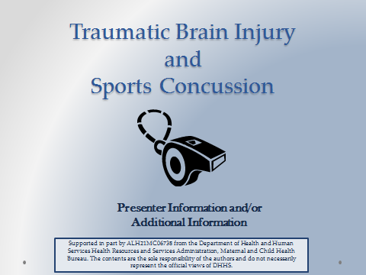
Suggested Materials and Resources:
- Handouts for AHIF, ADRS, Outreach and Education Brochure, CRS, Sports Concussion Flyer
- CDC Traumatic Brain Injury Materials: cdc.gov/TraumaticBrainInjury
Facts, Topic-Specific Information, Training, and “Heads Up” Campaign Material
- PreventingConcussions.org
- Concussion Clinic at Children's of Alabama: uabsportsmedicine.com

Date(s) of Training: ____________________ Speaker: _______________________________

Strongly Strongly
A. RATING OF THE MEETING: Agree Disagree
1. Participants had opportunity to participate. | 5 | 4 | 3 | 2 |  | 1
2. Presentations were well organized. | 5 | 4 | 3 | 2 |  | 1
3. Program content was relevant to my job. | 5 | 4 | 3 | 2 |  | 1
4. Length and pace were appropriate. | 5 | 4 | 3 | 2 |  | 1
Considerable Not
B. PERCEIVED IMPACT OF TRAINING: Impact Relevant
1. Positive effect of the meeting on my professional skills, knowledge, abilities. | 5 | 4 | 3 | 2 | 1
2. Positive effect of the meeting on people served in the rehabilitation service system. | 5 | 4 | 3 | 2 | 1

COMMENTS ON THIS TRAINING EVENT:

- What were the special strengths of the meeting?

- What were the weaknesses of the meeting?

- What changes and other topics would you recommend?

Additional Comments:

Strengthening the System of Care for Alabamians with TBI Date(s):_____________________________

Speaker:__________________________________ Location: ____________________________

Name | Organization & Ph. No. | Address | Email Address

Sign-In Continued
Name | Organization & Ph. No. | Address | Email Address

