Traumatic Brain Injury: Children and Youth Issues
Outreach and Education Training
Includes:
Training Summary and Objectives
Presentation Information
Evaluation Form
Sign-In Sheet

Supported in part by AL H21MC06738 from the Department of Health and Human Services Health Resources and Services Administration, Maternal and Child Health Bureau. The contents are the sole responsibility of the authors and do not necessarily represent the official views of DHHS.

Training Title:
Traumatic Brain Injury: Children and Youth Issues

Training Summary:
This presentation briefly describes some of the many traumatic brain injury related issues surrounding children and youth. Incidence and causes specific to this population is included as well as a general overview introduces of definitions, levels of severity, incidence rates, causes, risk factors, and effects of traumatic brain injury. Information about planning a return to school and who can provide assistance for a child with a traumatic brain injury are included. Audience will receive state-wide and national resources for traumatic brain injury, as well as specific resources for children and youth issues.

Training Objectives:
- Participants will be provided with an explanation of traumatic brain injury, as well as causes, effects, and prevalence.
- Participants will be familiarized with the incidence and some of the causes of TBI that are commonly associated with children and youth.
- Participants will be briefly exposed to information about brain development and the issues that surround a developing child with a traumatic brain injury.
- Participants will be provided with information regarding school support and accommodating the environment for a child with a traumatic brain injury.
- Participants will be provided with resources specific to children and youth with traumatic brain injury.
- Participants will be given information on accessing the resources available in Alabama for working with persons surviving brain injury and their caregivers.
Training Credit:
Continuing Education Units, or CEUs, are required by many professional licensing or certifying bodies. Therefore they are a valuable commodity to professionals who may be attending this Outreach and Education training. The application and approval of CEUs varies for each professional group and can require a great deal of documentation. For additional information on CEUs and Certificates of Attendance in connection with this training module, contact Maria Crowley at maria.crowley@rehab.alabama.gov or (205) 290-4590.

Power Point Presentation:
32 slides
Approximate presentation time: 30 -35 minutes
Presentation contains: Visual only with notes throughout.

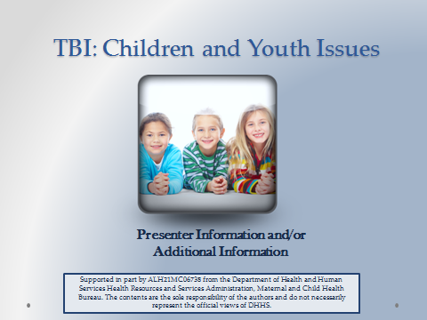
Suggested Materials and Resources:
Handouts for AHIF, ADRS, Outreach and Education Brochure, CRS, Early Intervention

CDC Traumatic Brain Injury Materials: cdc.gov/TraumaticBrainInjury
“Heads Up” Campaign Materials

ADAP Resource List or “Special Education: A Right Not a Favor” Booklet
adap.net/adap-pubs.

Date(s) of Training: ____________________ Speaker: _______________________________

Strongly Strongly
A. RATING OF THE MEETING: Agree Disagree
1. Participants had opportunity to participate. | 5 | 4 | 3 | 2 |  | 1
2. Presentations were well organized. | 5 | 4 | 3 | 2 |  | 1
3. Program content was relevant to my job. | 5 | 4 | 3 | 2 |  | 1
4. Length and pace were appropriate. | 5 | 4 | 3 | 2 |  | 1
Considerable Not
B. PERCEIVED IMPACT OF TRAINING: Impact Relevant
1. Positive effect of the meeting on my professional skills, knowledge, abilities. | 5 | 4 | 3 | 2 | 1
2. Positive effect of the meeting on people served in the rehabilitation service system. | 5 | 4 | 3 | 2 | 1

COMMENTS ON THIS TRAINING EVENT:

- What were the special strengths of the meeting?

- What were the weaknesses of the meeting?

- What changes and other topics would you recommend?

Additional Comments:

Strengthening the System of Care for Alabamians with TBI Date(s):_____________________________

Speaker:__________________________________ Location: ____________________________

Name | Organization & Ph. No. | Address | Email Address

Sign-In Continued
Name | Organization & Ph. No. | Address | Email Address

