Veterans with Traumatic Brain Injury
Outreach and Education Training
Includes:
Training Summary and Objectives
Presentation Information
Evaluation Form
Sign-In Sheet

Supported in part by AL H21MC06738 from the Department of Health and Human Services Health Resources and Services Administration, Maternal and Child Health Bureau. The contents are the sole responsibility of the authors and do not necessarily represent the official views of DHHS.

Training Title:
Veterans with Traumatic Brain Injury
Training Summary:
This presentation introduces traumatic brain injury issues related to veterans. A general overview describes the basic definitions, levels of severity, incidence, causes, risk factors, and effects associated with traumatic brain injury. Prevalence and causes of TBI in the military are identified and discussed. The process for screening for brain injuries is presented. Issues related to the service member returning to military duty, returning from theater, and transitioning from service to civilian is reviewed. The audience will receive state-wide and national resources for traumatic brain injury, as well as specific resources related to traumatic brain injury and veteran issues.

Training Objectives:
- Participants will be provided with an explanation of traumatic brain injury, as well as causes, effects, risk factors, mechanism, and prevalence.
- Participants will be provided with the prevalence and causes of traumatic brain injury in the military.
- Participants will be provided an explanation of risk and the screening process for traumatic brain injury in the military.
- Participants will be familiarized with the basics of blast injuries and the various types of blast injuries.
- Participants will be familiarized with service member issues such as returning to military duty, post-deployment, and transition from the military as it relates to traumatic brain injury.
- Participants will be given information on accessing the resources available in Alabama for persons surviving brain injury and their caregivers, specific resources related to traumatic brain injury and veteran issues.

Training Credit:
Continuing Education Units, or CEUs, are required by many professional licensing or certifying bodies. Therefore they are a valuable commodity to professionals who may be attending this Outreach and Education training. The application and approval of CEUs varies for each professional group and can require a great deal of documentation. For additional information on CEUs and Certificates of Attendance in connection with this training module, contact Maria Crowley at maria.crowley@rehab.alabama.gov or (205) 290-4590.

Power Point Presentation:
35 slides
Approximate presentation time: 30-35 minutes
Presentation contains: Visual only with notes throughout.
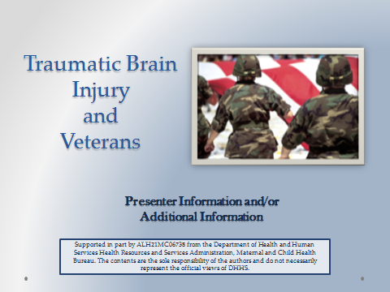
Suggested Materials and Resources:
- Handouts for AHIF, ADRS, Outreach and Education Brochure, SAIL
CDC Traumatic Brain Injury Materials: www.cdc.gov/TraumaticBrainInjury
- Brain Injury Association of New York State: BIANYS.org
  - Documentary Films on Veterans and BI
  - Webinar with slides “Meeting the Needs of Student Veterans: The Impact of Traumatic Brain Injury.”
- TraumaticBrainInjuryAtoZ.org Materials:
  - Caregiver Curriculum (Downloadable)
- Center for the Study of Traumatic Stress: www.cstsonline.org
  - Many printable fact sheets and informational pages
Date(s) of Training: ____________________ Speaker: _______________________________

Strongly Strongly
A. RATING OF THE MEETING: Agree Disagree
1. Participants had opportunity to participate. | 5 | 4 | 3 | 2 |  | 1
2. Presentations were well organized. | 5 | 4 | 3 | 2 |  | 1
3. Program content was relevant to my job. | 5 | 4 | 3 | 2 |  | 1
4. Length and pace were appropriate. | 5 | 4 | 3 | 2 |  | 1
Considerable Not
B. PERCEIVED IMPACT OF TRAINING: Impact Relevant
1. Positive effect of the meeting on my professional skills, knowledge, abilities. | 5 | 4 | 3 | 2 | 1
2. Positive effect of the meeting on people served in the rehabilitation service system. | 5 | 4 | 3 | 2 | 1

COMMENTS ON THIS TRAINING EVENT:

- What were the special strengths of the meeting?

- What were the weaknesses of the meeting?

- What changes and other topics would you recommend?

Additional Comments:

Strengthening the System of Care for Alabamians with TBI Date(s):_____________________________

Speaker:__________________________________ Location: ____________________________

Name | Organization & Ph. No. | Address | Email Address

Sign-In Continued
Name | Organization & Ph. No. | Address | Email Address

