Traumatic Brain Injury and Seniors
Outreach and Education Training
Includes:
Training Summary and Objectives
Presentation Information
Evaluation Form
Sign-In Sheet

Supported in part by AL H21MC06738 from the Department of Health and Human Services Health Resources and Services Administration, Maternal and Child Health Bureau. The contents are the sole responsibility of the authors and do not necessarily represent the official views of DHHS.

Training Title:
Traumatic Brain Injury and Seniors

Training Summary:
This presentation briefly describes the incidence, prevalence, causes and basic effects of brain injury on seniors, along with a general overview of traumatic brain injury. Prevention of falls and available resources are discussed.

Training Objectives:
- Participants will be provided with an explanation of traumatic brain injury, as well as causes, effects, and prevalence.
- Participants will be familiarized with the incidence, prevalence and causes of TBI in seniors.
- Participants will be familiarized with the mechanism of brain injury and its effects on seniors.
- Participants will be provided with methods for preventing brain injury and falls in seniors.
- Participants will be given information on accessing the resources available in Alabama for working with persons surviving brain injury and their caregivers.

Training Credit:
Continuing Education Units, or CEUs, are required by many professional licensing or certifying bodies. Therefore they are a valuable commodity to professionals who may be attending this Outreach and Education training. The application and approval of CEUs varies for each professional group and can require a great deal of documentation. For additional information on CEUs and Certificates of Attendance in connection with this training module, contact Maria Crowley at maria.crowley@rehab.alabama.gov or (205) 290-4590.

Power Point Presentation:
27 slides
Approximate presentation time: 25-30 minutes
Presentation contains: Visual only with a few notes throughout.
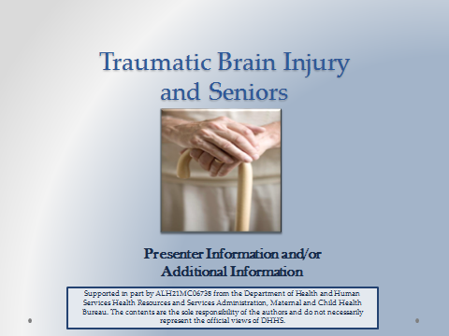
Suggested Materials and Resources:
Handouts for AHIF, ADRS, Outreach and Education Brochure, SAIL

CDC "Help Seniors Live Better, Longer: Prevent Brain Injury" Materials
www.cdc.govtraumaticbrainInjury/seniors
Fact sheets, posters, e-cards, brochures

CDC Traumatic Brain Injury Materials
http://www.cdc.gov/TraumaticBrainInjury/index.html
Overview of TBI and effects for general population
Date(s) of Training: ____________________ Speaker: _______________________________

Strongly Strongly
A. RATING OF THE MEETING: Agree Disagree
1. Participants had opportunity to participate. | 5 | 4 | 3 | 2 |  | 1
2. Presentations were well organized. | 5 | 4 | 3 | 2 |  | 1
3. Program content was relevant to my job. | 5 | 4 | 3 | 2 |  | 1
4. Length and pace were appropriate. | 5 | 4 | 3 | 2 |  | 1
Considerable Not
B. PERCEIVED IMPACT OF TRAINING: Impact Relevant
1. Positive effect of the meeting on my professional skills, knowledge, abilities. | 5 | 4 | 3 | 2 | 1
2. Positive effect of the meeting on people served in the rehabilitation service system. | 5 | 4 | 3 | 2 | 1

COMMENTS ON THIS TRAINING EVENT:

- What were the special strengths of the meeting?

- What were the weaknesses of the meeting?

- What changes and other topics would you recommend?

Additional Comments:

Strengthening the System of Care for Alabamians with TBI Date(s):_____________________________

Speaker:__________________________________ Location: ____________________________

Name | Organization & Ph. No. | Address | Email Address

Sign-In Continued
Name | Organization & Ph. No. | Address | Email Address

