Traumatic Brain Injury and Substance Abuse
Outreach and Education Training
Includes:
Training Summary and Objectives
Presentation Information
Evaluation Form
Sign-In Sheet

Supported in part by AL H21MC06738 from the Department of Health and Human Services Health Resources and Services Administration, Maternal and Child Health Bureau. The contents are the sole responsibility of the authors and do not necessarily represent the official views of DHHS.

Training Title:
Traumatic Brain Injury and Substance Abuse

Training Summary:
This presentation briefly describes substance abuse as it relates to individuals with traumatic brain injury. A general overview introduces the audience to basic definitions, levels of severity, incidence rates, causes, risk factors, and effects of traumatic brain injury. Information about pre-injury and post-injury substance abuse will be included. Suggestions for treating a client with a traumatic brain injury and substance abuse issues are discussed. The audience will receive state-wide and national resources for traumatic brain injury, as well as substance abuse.

Training Objectives:
- Participants will be provided with an explanation of traumatic brain injury, as well as causes, effects, and prevalence.
- Participants will be familiarized with the relationship between substance abuse and traumatic brain injury.
- Participants will be familiarized with the effect of substance use in the recovery of traumatic brain injury.
- Participants will be provided suggestions on accommodating the client with a traumatic brain injury in a substance abuse treatment program.
- Participants will be given resources specifically related to substance abuse and traumatic brain injury.
- Participants will be given information on accessing the resources available in Alabama for working with persons surviving brain injury and their caregivers.

Training Credit:
Continuing Education Units, or CEUs, are required by many professional licensing or certifying bodies. Therefore they are a valuable commodity to professionals who may be attending this Outreach and Education training. The application and approval of CEUs varies for each professional group and can require a great deal of documentation. For additional information on CEUs and Certificates of Attendance in connection with this training module, contact Maria Crowley at maria.crowley@rehab.alabama.gov or (205) 290-4590.

Power Point Presentation:
29 slides
Approximate presentation time: 30-35 minutes
Presentation contains: Visual only with notes throughout.

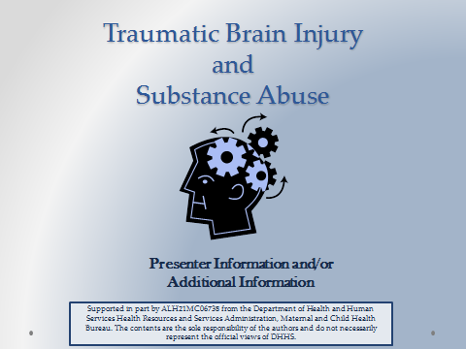

Suggested Materials and Resources:
The links below are long but are useful resources.
- Handouts for AHIF, ADRS, Outreach and Education Brochure, SAIL
- CDC Traumatic Brain Injury Materials - cdc.gov/TraumaticBrainInjury
- BIAA Substance Abuse Issues after BI Booklet
www.biausa.org/LiteratureRetrieve.aspx?ID=43235
- 12 Steps Booklet for Brain Injury and Addictive Disorders (TexasNeuroRehab.com) (pdf)
- Substance Use/Brain Injury Bridging Project
www.brainline.org/downloads/PDFs/SUBIClientWorkbook.pdf
- Mt. Sinai School of Medication- Rehab Medicine Dept.
http://www.mssm.edu/static_files/MSSM/Files/Research/Centers/Traumatic%20Brain%20Injury%20Central/CR6.pdf
- SAMSHA TBI and Substance Abuse Publication
http://www.kap.samhsa.gov/products/manuals/advisory/pdfs/Advisory_TBI.pdf
- BIA New Jersey Articles – Family Guide to Alcohol… after Brain Injury
http://bianj.org/Websites/bianj/images/Family%20Guide%20to%20Use%20of%20Alcohol%20and%20Other%20Substances%20after%20Brain%20Injury.pdf
- Suggestions for Substance Abuse Treatment Providers Working with Persons Who Have Limitations in Cognitive Abilities
https://ckm.osu.edu/sitetool/sites/ohiovalleypublic/documents/Suggestions.pdf

Date(s) of Training: ____________________ Speaker: _______________________________

Strongly Strongly
A. RATING OF THE MEETING: Agree Disagree
1. Participants had opportunity to participate. | 5 | 4 | 3 | 2 |  | 1
2. Presentations were well organized. | 5 | 4 | 3 | 2 |  | 1
3. Program content was relevant to my job. | 5 | 4 | 3 | 2 |  | 1
4. Length and pace were appropriate. | 5 | 4 | 3 | 2 |  | 1
Considerable Not
B. PERCEIVED IMPACT OF TRAINING: Impact Relevant
1. Positive effect of the meeting on my professional skills, knowledge, abilities. | 5 | 4 | 3 | 2 | 1
2. Positive effect of the meeting on people served in the rehabilitation service system. | 5 | 4 | 3 | 2 | 1

COMMENTS ON THIS TRAINING EVENT:

- What were the special strengths of the meeting?

- What were the weaknesses of the meeting?

- What changes and other topics would you recommend?

Additional Comments:

Strengthening the System of Care for Alabamians with TBI Date(s):_____________________________

Speaker:__________________________________ Location: ____________________________

Name | Organization & Ph. No. | Address | Email Address

Sign-In Continued
Name | Organization & Ph. No. | Address | Email Address

